Payroll Management System for Information Technology Company

Version 1.0

Revision History

|  |  |  |  |
| --- | --- | --- | --- |
| **Date** | **Version** | **Description** | **Author** |
| 16/12/2019 | 1.0 | Final | Quản Trọng Tú |
|  |  |  |  |
|  |  |  |  |
|  |  |  |  |

Table of Contents

1. Use-Case Name 4

1.1 Brief Description 4

2. Flow of Events 4

2.1 Basic Flow 4

3. Special Requirements 5

4. Preconditions 5

5. Postconditions 5

6. Extension Points 5

Adding Working-Time

# Use-Case Name

## Brief Description

This use case defines the steps of adding a new project to store it in the database system. Administrator can easily add a new project and assign this for each user in a company.

# Flow of Events

## Basic Flow

The Administrator access to Manage Project view to do adding project function. The admin clicks on add button to create Adding form. The administrator sets database management parameter that holds Project information that has just added. The system will display the new value in the table.

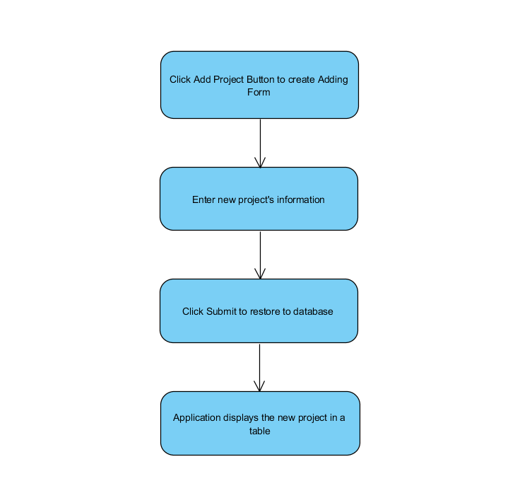

Basic flow of adding new project

# Special Requirements

Because the purpose this system is calculate the salary of user, when adding new Project, administrator have to focus on total earning.

# Preconditions

* Administrator have to login into application and access Manage Project view.
* User determine the total earning of this project.

# Postconditions

* Project information displays in a table automatically.

# Extension Points

No extension points.